**Technical Design Document**

Author: Jacob Dominski

**Description of Application**

This project aims to create a faster and more efficient workflow within my client’s company. My application will be catered towards the HVAC industry where a big portion of that industry still use pen and paper. Additionally, the application will be supported on both iOS and Android although it will have better optimization for iOS because that is the operating system my client uses. My idea would let the technician create the proposal while on the job to decreasing the time taken to get the customer to agree to the proposal. This would increase workflow and efficiency by approximately 25% – 30%. The app works by letting the technician create a form where they select the options the customer needs for an AC unit installation. Then, it will generate a form where both the customer and the technician will sign the document and an email will be sent to both the company and the customer so work can begin.

**Objectives**

Objective 1 - Core Functionality. Completion date: February 14th, 2021

          Activity a - Build the Framework UI that the user can navigate and see different screens.

          Activity b - Make it User Friendly

          Activity c - Add the settings window

          Activity d - Add functionality to generate a basic proposal

          Activity e - Include basic options the user can select

Objective 2 - Add a PDF Viewer Component. Completion date: February 28th, 2021

          Activity a - Implement a PDF viewer component

          Activity b - Add the component after the user has selected the options for the proposal

          Activity c - Add a required tag to some of the options that prevents the user from moving to the PDF Viewer

          Activity d - Add a back button in case the user chose incorrect options

          Activity e - Include legal text in the proposal and format the text based on the options the user chose

          Activity f - Implement a complete button that finalizes the component

Objective 3 - Implement a local save feature (Final version will store data in a database). Completion date: March 28th, 2021

          Activity a - all previous finalized proposals will be saved locally for the prototype. For the final version, they will be stored in a database and the mobile app will pull data from it and display it to the user

          Activity b - add a search bar at the top to look for proposals

          Activity c - add a default sort option in the settings by either data oldest or newest or alphabetical (forward or reverse for both first name and last name).

          Activity d - The UI will be displayed as a card where it will show the customer's name, email address, and the technician who filled out the proposal

Objective 4 - Create a Database to store company proposals (Final version only). Completion date: May 16th, 2021

          Activity a - Set up database using Google Firebase

          Activity b - Implement a login and registration form for the application

          Activity c - Companies will register with the company email and employees will register and include their company's email.

          Activity d - store data (most likely in a json format) in the data base that the mobile app can pull from

          Activity e - implement a backend script to send emails to customers and the company

**Code Plan Flow Chart**

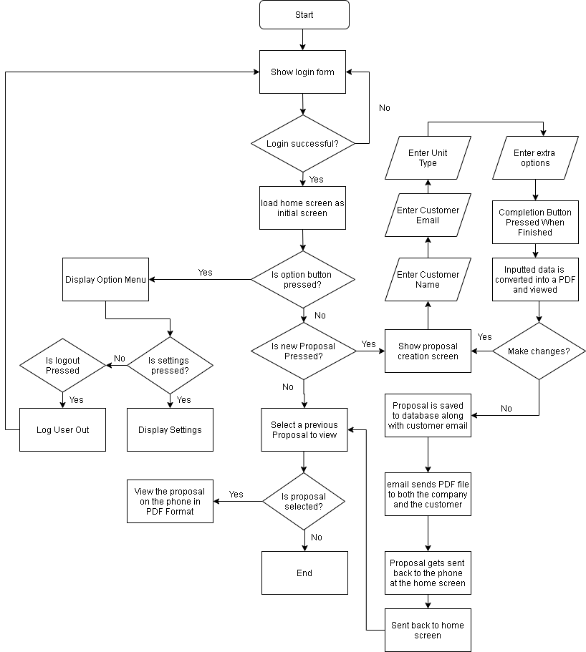

**Wireframe**

